EXERCISE PICTURE | INSTRUCTIONS
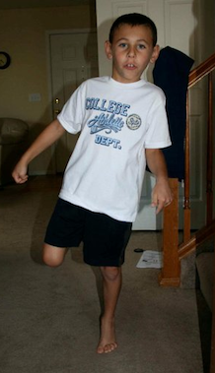 | SINGLE LEG HEEL RAISES:  Come up on your toes on the right foot and then repeat on the left foot. Do ______ sets x ________ repetitions.
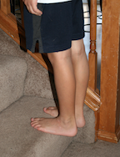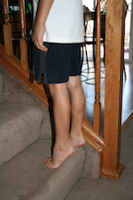 | STAIR HEEL RAISES:  Stand with both feet on a step with both of your heels over the edge. Let your heels drop downwards. Push up on your toes, trying to make an arch with your foot. Do ________ sets x _______ repetitions.
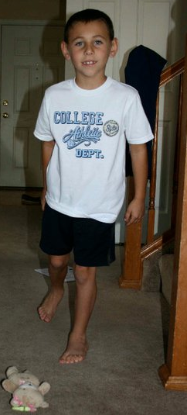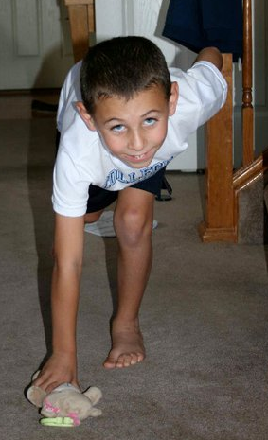 | DYNAMIC SINGLE LEG STANCE:  Balancing on one leg, squat down to pick up objects on the floor, returning to standing each time. Do ______ sets x _____ repetitions on each leg.
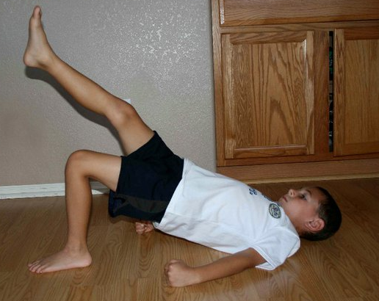 | SINGLE LEG BRIDGES:  Lie on your back, straighten right leg and hold. With left foot on the floor, lift hips up in a bridge position. Repeat with the leg lifted and right foot on the floor. Hold ______ seconds, repeat ______ times per side.
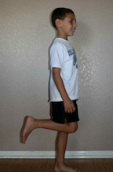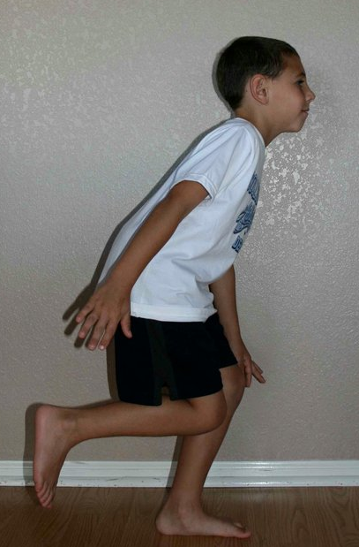 | SINGLE LEG SQUAT:  Using a ball being you against the wall, stand on one leg and squat down. Do _____ sets x ______ repetitions each leg.  Standing in the middle of the room, balance on one leg and squat down. Keep your back straight. Do ______ sets x _______ repetitions each leg.
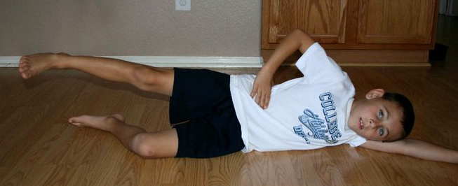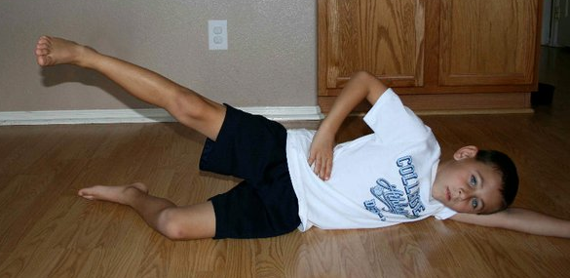 | HIP STRENGTHENING:  Lie on your side with hips in line with each other. Slowly raise your top leg up, making sure to keep hip and knee straight while rotating knees slightly up towards the ceiling. Do _______ sets x _______ repetitions.
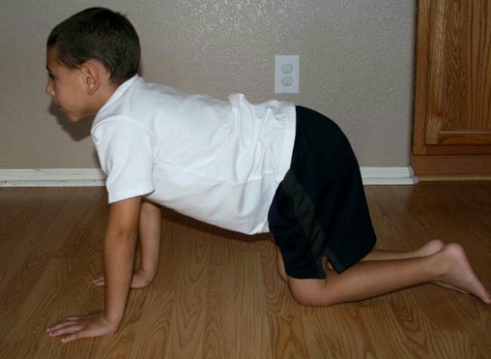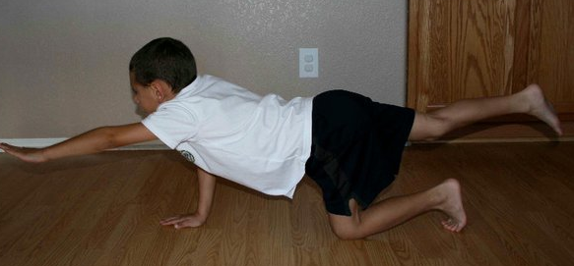 | CORE STRENGTHENING:  Get down on all fours. With your abdominal muscles tight, lift opposite arm and leg to horizontal position. Try to keep your body still while you hold for ______ seconds. Repeat _______ times on each side.
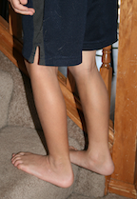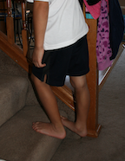 | CALF STRETCHING OFF OF A STEP:  With your shoes on, hang your foot off of a step (trying to keep an arch in your foot) until you feel a stretch in your calf muscle. Do _______ sets x _______ seconds each foot.

